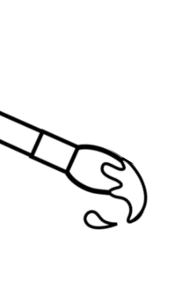
Welcome to
Torrington Middle School

A pencil

ART

Mrs. Colleen Boland rm#121 Mr. Victor Preato rm#122 Ms. Sandy Theriault rm#123 cboland@torrington.org vpreato@torrington.org stheriault@torrington.org
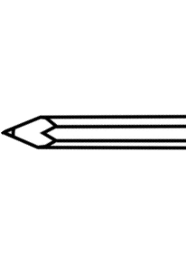
This course is filled with projects and activities that will boost your critical thinking habits, improve your
ability to focus, grow your creativity and develop your communication skills through writing, talking about and producing art.

In this class you will…

Materials needed daily:

• Organize and conceptualize artistic ideas.

• Refine and complete artistic work.

• Relate knowledge and personal
experiences to make art.

• Relate artistic ideas and works with societal,
cultural and historical context to deepen
understanding.

• Analyze, interpret, and select artistic work for
presentation.
• Interpret intent and meaning in artistic work.
(National Core Art Anchor Standards)

Class assignments:
Studio projects > Daily class participation >
Collaborative projects > Written assignments and quizzes
Student expectations:
Respect, Responsibility & Safety

An old T-shirt for smock(optional)
And a growth mindset!
Grading:
Each studio project will be assigned a grade based on percentage. Forms of assessment will include, student self-assessment as well as instructor assessment. Both forms of assessment will be based on specific objectives for each assignment. Much of the work will be assessed using the Studio Habits of Mind:

• Develop Craft • Observe
• Reflect • Engage & Persist
• Stretch & Explore • Envision
• Understand Art World • Express

Additionally, there will be 2 grades given for effort and behavior and they will be averaged with all other grades. The grading scale will follow Torrington public school’s district grading policy.
Hetland L., Winner, E., Veenam S., Sheridan, K. (2013) Studio Thinking 2: The Real
Benefits of a Visual Arts Education, NY: Teachers College Press

Please sign and return as this will be counted as a grade
Thank you.

Parent/Guardian signature ______________________________
Student signature _______________________________________

